|  |  |
| --- | --- |
| **CONSERVATORY of MUSIC and DRAMA**  ASSIGNMENT COVERSHEET |  |

Please Type or Print Clearly

|  |  |
| --- | --- |
| Name | Liang-Hao Kwan (Leon) |
| Student Number | D16123199 |
| Course/Year | BMus/ Year 4 |
| Module/Unit | Studies in Music History & Perf Practice 2/ English Musical Renaissance |
| Lecturer | Dr Maria McHale |
| Essay Title | The Contribution of Vaughan Williams to English Musical Renaissance |
| Word Count*  Number of Pages | 1258 Words  7 Pages |
| Deadline for Submission | 28 May 2020 |
| Date of Submission | 27 May 2020 |

If the assignment is being submitted after the due date, has an extension been

granted? Yes ☐ No ☐ N/A ☐

If an extension has been granted, please attach the completed/approved Extension Request Form.

**Declaration**

The material submitted is my own work and all information gleaned from other sources is appropriately referenced.

**Signed** _______Liang Hao Kwan__________ **Date** ____27 May 2020___

* Word count is inclusive of footnotes but exclusive of the bibliography.

**The Contribution of Vaughan Williams to English Musical Renaissance**  
  
 Vaughan Williams was born with a privileged background in 1872 and died in 1958. He studied with Stanford and Parry from RCM, Bruch in Berlin, and Ravel in Paris. Because of that, his music is strongly influenced by Stanford and Parry’s musical language and Ravel’s eminent orchestration. Further, Stanford and Parry’s musical language were German based that had been the main style of English music throughout the nineteenth century. Besides that, Vaughan Williams were also influenced by Tudor composers and English folksong. He joined the English folksong society and became an enthusiastic collector and editor of folksong and hymns. Vaughan Williams had progressed English music to become more “English”, rather than staying in German-dominated style. This essay will discuss his contributions to English Musical Renaissance.

Looking back to the pastoral past was viewed as a progressive move to English Musical Renaissance. Because of the urbanisation and wars, the rural lifestyle had become an irrecoverable past. Therefore, pastoralism in music is really a romanticised view of the rural past. The pastoral influences strongly impacted Vaughan Williams’s writings on melody, rhythm, and harmony. Which also can be seen in every composition he had composed. In addition, Vaughan Williams has the musical characteristics of folksong, but there is no direct quotation of folksong. In his one of his early works, *The Lark Ascending* is a good example to shows the pastoral elements. The work begins with the subtle harmonies in Dorian mode, a mode which often used in many folksongs. Then, the solo violin plays in the pentatonic scale. Moreover, the introduction of solo violin’s cadenza is unmetered, to create the sense of free and folk-like singing style.

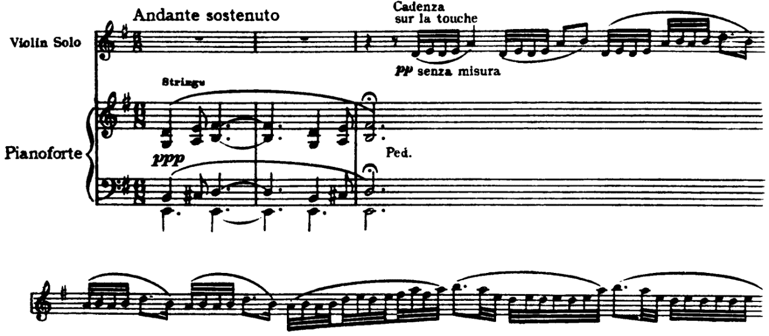

Figure 1 Vaughan Williams, The Lark Ascending, opening violin cadenza in pentatonic scale ([Audio Example](http://www.youtube.com/watch?v=xUxYtr1Z1VY&t=0m20s))

Apart from that, *Fantasia on a theme by Thomas Tallis* is also a notable work representing his pastoralism in music. The work is based on a modal hymn *why fum’th in fight* by Thomas Tallis from Tutor period. The hymn is in Phrygian mode, which creates the sense of sonority.

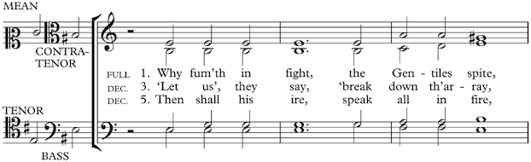

Figure 2 Tallis, why fum’th in fight ([Audio Example](http://www.youtube.com/watch?v=lD5TG8z3-SM&t=0m0s))

On top of that, the harmonies of Phrygian mode also bring the haunting atmosphere into the music, however the work is not fully modal or diatonic. Furthermore, the work also has flexible rhythm and form. For instance, the frequent change of meters throughout the music.

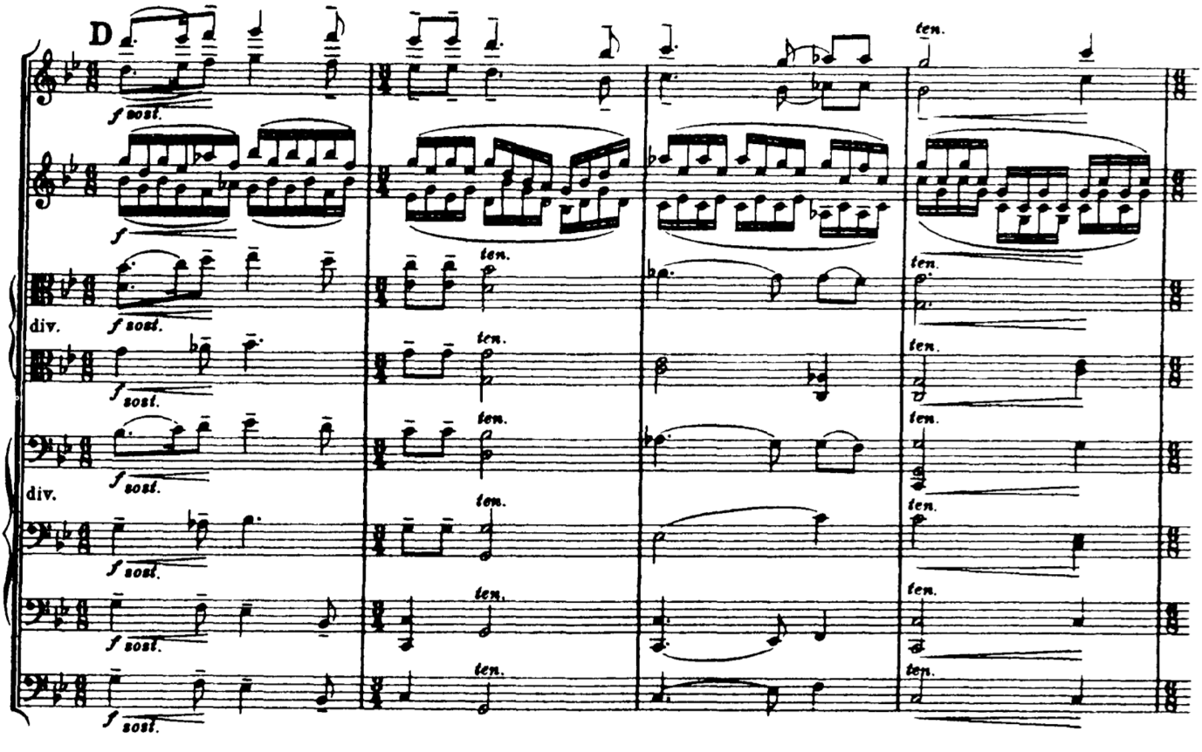

Figure 3 Vaughan Williams, Fantasia on a theme by Thomas Tallis ([Audio Example](http://www.youtube.com/watch?v=qIhZbvlCjY0&t=3m11s))

Vaughan Williams was one of the first English composers that associated with the influence of Ravel and Debussy. The French musical style influenced Vaughan Williams greatly in his harmony and sonority, which is also a progressive move to English Music Renaissance. The sound world of Vaughan Williams’s works is also influenced by the French musically style. As he often applied static strings beneath the melody in his orchestration, which French composers had done, especially Debussy. But the difference is Vaughan Williams’s harmonic palate is more associated with modal and pentatonic language. For example, the sonority of his second symphony, *London Symphony*, is similar to Debussy’s *La Mer*; even the approach to the introduction of both works are alike.[1] At this stage, his musical language had become less utopian but more dystopian. Additionally, Vaughan Williams’s third symphony is the perfect example to present the influence from the French. The symphony consisted of four movements that are fairly similar to each other, in terms of the sound world. And once again, most of the time, modal harmony is used to show the pastoral nuance in the work. The work begins with an introduction with block parallel chords to create a deep calm atmosphere. This often pointed out to compared with the similarity to the opening of Debussy’s *Nuages*.

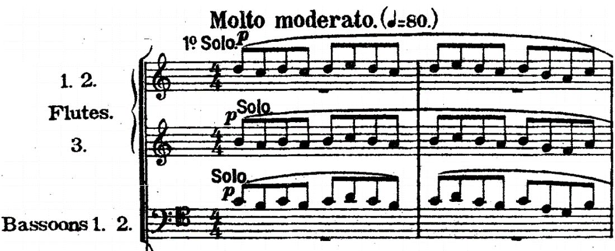

Figure 4 Vaughan Williams, Pastoral Symphony, opening block parallel chords ([Audio Example](http://www.youtube.com/watch?v=-KF2Kb6pIaE&t=0m12s))

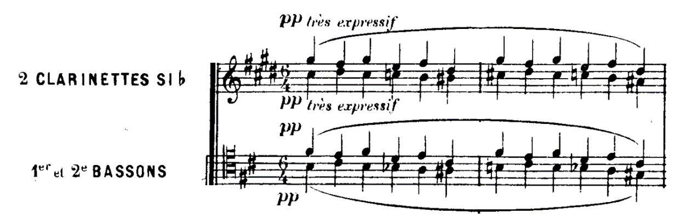

Figure 5 Debussy, Nuages, opening block parallel chords ([Audio Example](http://www.youtube.com/watch?v=spXwXLqFLvs&t=0m5s))

In the later movements in the symphony, the programmatic elements have become more strongly. In centre of the second movement, the natural trumpet plays the rising-fifth motif, act as a bugle call, over a static modal accompaniment.

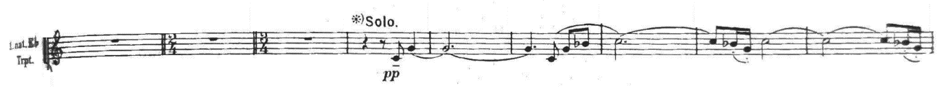

Figure 6 Vaughan Williams, Pastoral Symphony, II, Bugle Call ([Audio Example](https://www.youtube.com/watch?v=-KF2Kb6pIaE&t=17s))

Apart from that, the last movement employed a solo offstage soprano singing a wordless melodic line in free time, acting as a lament, which again demonstrates the folk-like elements of the work.



Figure 7 Vaughan Williams, Pastoral Symphony, IV, wordless melody ([Audio Example](http://www.youtube.com/watch?v=-KF2Kb6pIaE&t=24m22s))

However, it is arguable to say this symphony is programmatic. With the title ‘Pastoral’, often brings misconceptions to people. Due to the title, people’s assumption on the work was ‘programmatic’. But according to his letter to his wife Ursula Wood in 1938, he declared that the work is a war-time music. Besides, the musical elements seem to be programmatic too.

After the *Pastoral Symphony*, Vaughan Williams’s harmony language had become more advanced and matured in later works. Besides modality and pentatonicism, he explored polymodality, bitonality, diatonicism, and octatonicism. These modernist musical languages are the most progressive move to the English Musical Renaissance at that time. His tragic opera *Riders to the Sea* is one of his best works that well demonstrates the modernist musical language. There is a triadic juxtaposition employed in the opening of the work, which implied C minor triad and D-flat major triad with a missing third. This bitonal opening provides the uncanny sounding, which is the representative of the unsettling sea storm.

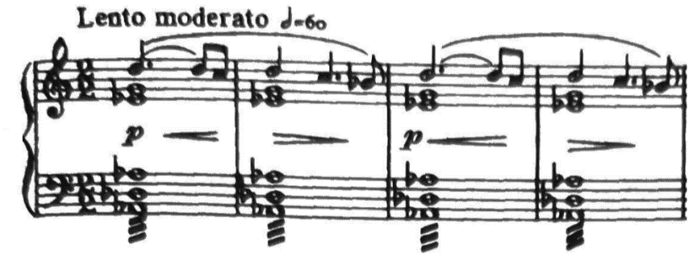

Figure 8 Vaughan Williams, Riders to the Sea, bitoanl opening ([Audio Example](https://www.youtube.com/watch?v=xjSw8YxbnY8&list=OLAK5uy_lMR118QW5bDqwcGzJdS7EADQpMLsWjsiY))

In the opening lines of Nora and Cathleen, it applied octatonic scale in the melody. This scale added the harshness to the music. Further, combining with the Hiberno-English style in the text enhanced the harshness of the music, which perfectly associates with the story.

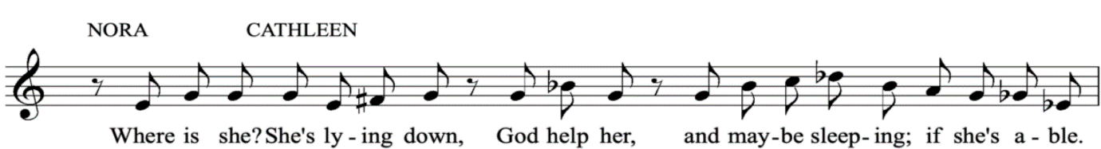

Figure 8 Vaughan Williams, Riders to the Sea, opening lines of Nora and Cathleen ([Audio Example](http://www.youtube.com/watch?v=xjSw8YxbnY8&t=2m0s))

Maurya’s ‘They are all gone now’ in the end of the opera, the harmonic language has moved from the harsh musical language to more calm and consonant harmony. The diatonic harmonic language is used to represent Maurya’s acceptance of all her sons’ death. This unsettling calmness is also showing her sense of relief and peace, because the sea can do no more damage to her family since all her sons are dead. In addition, Vaughan Williams the text setting of the opera is declamatory and almost speech-like. There are typical Irish expressions in the text, such as “god help her” and "after bringing them”. This style of the language is called Hiberno-English, which Synge picked up in his travels. Once again, the French influence also shows in *Rider to the Sea*. The sound world created by the scanty orchestral setting accompanying a realistic setting of the French language in Debussy’s only opera, *Pelléas et Mélisande*, is similar to the sound world of *Riders to the Sea*.

In conclusion, Vaughan Williams had become a vital composer to English Music Renaissance. This essay has covered the aspects and influences of his musical language and contributions to the English music. The pastoralism is the most important contribution in his music. It significantly influenced his writing on harmony, such as modality and polymodality; modal keys and pentatonic scales on melodic writing; and lastly the looser writing on rhythm and meter. Not even that, the text setting he used in his opera, *Riders to the Sea*, is also set in Hiberno-English. Moreover, the French influence in his music introduced the sonority, uncanny harmonies, and the static background. Lastly, Vaughan Williams pushed his harmony language to a more dissonant sounding, which is a significant contribution in English Musical Renaissance.

Bibliography

Book

Philip, Robert: *The Classical Music Lover's Companion to Orchestral Music* (London: Yale University Press, 2018).

1. Philip, Robert: *The Classical Music Lover's Companion to Orchestral Music: RALPH VAUGHAN WILLIAMS* (London: Yale University Press, 2018).